Example 1: Control Structures

Q1.

*Initial Loans and Customers Tables:*

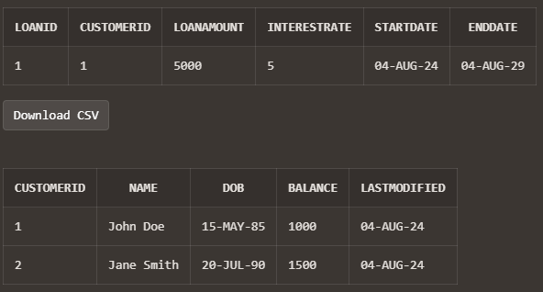

*PL/SQL Block:*

DECLARE

v_customer_id Customers.CustomerID%TYPE;

v_dob Customers.DOB%TYPE;

v_age NUMBER;

v_loan_id Loans.LoanID%TYPE;

v_interest_rate Loans.InterestRate%TYPE;

CURSOR c_customers IS

SELECT CustomerID, DOB

FROM Customers;

CURSOR c_loans(p_customer_id NUMBER) IS

SELECT LoanID, InterestRate

FROM Loans

WHERE CustomerID = p_customer_id;

BEGIN

FOR customer_rec IN c_customers LOOP

-- Calculate age

v_age := TRUNC(MONTHS_BETWEEN(SYSDATE, customer_rec.DOB) / 12);

-- Check if customer is above 60

IF v_age > 60 THEN

-- Loop through customer's loans

FOR loan_rec IN c_loans(customer_rec.CustomerID) LOOP

-- Apply 1% discount

v_interest_rate := loan_rec.InterestRate - 1;

-- Ensure interest rate doesn't go below 0%

v_interest_rate := GREATEST(v_interest_rate, 0);

-- Update loan interest rate

UPDATE Loans

SET InterestRate = v_interest_rate

WHERE LoanID = loan_rec.LoanID;

-- Log the change

DBMS_OUTPUT.PUT_LINE('Updated loan ' || loan_rec.LoanID ||

' for customer ' || customer_rec.CustomerID ||

'. New interest rate: ' || v_interest_rate || '%');

END LOOP;

END IF;

END LOOP;

COMMIT;

DBMS_OUTPUT.PUT_LINE('Process completed successfully.');

EXCEPTION

WHEN OTHERS THEN

ROLLBACK;

DBMS_OUTPUT.PUT_LINE('An error occurred: ' || SQLERRM);

END;

/

*Output:*

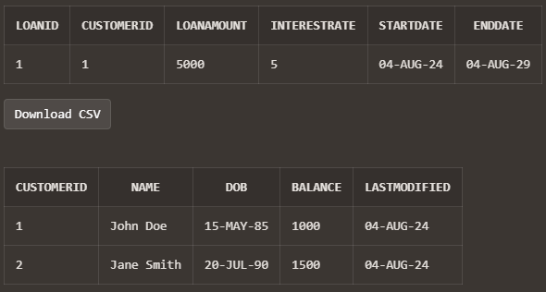

The Interest Rate didn’t change because “John Doe” isn’t 60 years old

Q2.

*Initial Customers Table:*

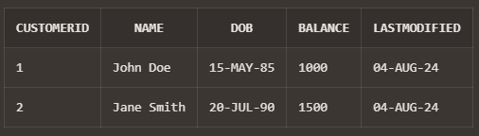

*PL/SQL Block:*

ALTER TABLE Customers ADD IsVIP NUMBER(1) DEFAULT 0;

DECLARE

CURSOR c_customers IS

SELECT CustomerID, Balance

FROM Customers;

v_vip_threshold NUMBER := 10000; -- $10,000 threshold for VIP status

v_updated_count NUMBER := 0;

BEGIN

FOR customer_rec IN c_customers LOOP

IF customer_rec.Balance > v_vip_threshold THEN

-- Update customer to VIP status

UPDATE Customers

SET IsVIP = 1

WHERE CustomerID = customer_rec.CustomerID;

v_updated_count := v_updated_count + 1;

ELSE

-- Ensure non-VIP status for customers below threshold

UPDATE Customers

SET IsVIP = 0

WHERE CustomerID = customer_rec.CustomerID;

END IF;

END LOOP;

COMMIT;

DBMS_OUTPUT.PUT_LINE('Process completed. ' || v_updated_count || ' customers updated to VIP status.');

EXCEPTION

WHEN OTHERS THEN

ROLLBACK;

DBMS_OUTPUT.PUT_LINE('An error occurred: ' || SQLERRM);

END;

/

*Output:*

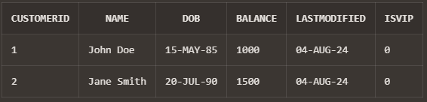

Q3.

*Initial Customers and Loans Tables:*

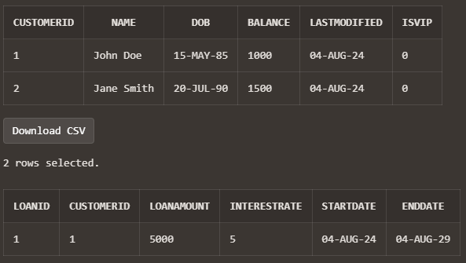

*PL/SQL Block:*

DECLARE

CURSOR c_due_loans IS

SELECT l.LoanID, l.CustomerID, c.Name, l.LoanAmount, l.EndDate

FROM Loans l

JOIN Customers c ON l.CustomerID = c.CustomerID

WHERE l.EndDate BETWEEN SYSDATE AND SYSDATE + 30;

v_reminder_count NUMBER := 0;

BEGIN

FOR loan_rec IN c_due_loans LOOP

DBMS_OUTPUT.PUT_LINE('Reminder for Loan ID: ' || loan_rec.LoanID);

DBMS_OUTPUT.PUT_LINE('Dear ' || loan_rec.Name || ',');

DBMS_OUTPUT.PUT_LINE('This is a reminder that your loan of $' ||

TO_CHAR(loan_rec.LoanAmount, '999,999.99') ||

' is due on ' || TO_CHAR(loan_rec.EndDate, 'YYYY-MM-DD') || '.');

DBMS_OUTPUT.PUT_LINE('Please ensure timely repayment to avoid any late fees.');

DBMS_OUTPUT.PUT_LINE('-------------------------------------------');

v_reminder_count := v_reminder_count + 1;

END LOOP;

IF v_reminder_count > 0 THEN

DBMS_OUTPUT.PUT_LINE('Total reminders generated: ' || v_reminder_count);

ELSE

DBMS_OUTPUT.PUT_LINE('No loans are due within the next 30 days.');

END IF;

EXCEPTION

WHEN OTHERS THEN

DBMS_OUTPUT.PUT_LINE('An error occurred: ' || SQLERRM);

END;

/

*Output:*

